1) HDFS 10 points

Running any version of Hadoop (docker or otherwise), submit screen grabs (a picture in jpg or other suitable format) of the following:

a) create a directory on HDFS with your first name and the date (e.g. mine will be ‘juan-march - 01’). Submit a screen grab of the output of a Hadoop fs listing showing your home directory and your new directory in it.



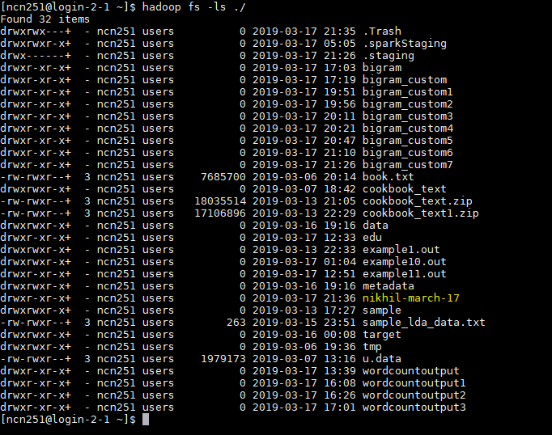

b) Create a directory for the homework problem 1.2 (bigram count), and extract all input files into it. Call this directory as follows: netid-hw1-2, e.g. mine will be jcr365-hw1-2. Submit a picture of directory listings or otherwise show the input files in it.

